I am trying to find documents being prepared by the Belgian Ministry of Education (www.enseignement.be) related to the exams of CE1d to be passed in June 2017, by students who have completed the first 2 years of the secondary school. This exam is called: CE1d. Three sections are of interest: Mathematics (in French: MATHEMATIQUES), Sciences (same in French: SCIENCES), French (in French: FRANCAIS).
On the aforementioned site: www.enseignement.be, when the preparation of the documents is completed, these exams are listed among 4 horizontal windows, as follows:
FRANCAIS |  | MATHEMATIQUES |  | LANGUES MODERNES |  | SCIENCES
( We have no interest in LANGUES MODERNES)
Below these windows, there is the following text:
Questionnaires (Questionnaires also in English)
Dossier de l’enseignant (Dossier for the teacher)
Résultats (Results)

Working groups are assigned to each of these 3 areas of interest of this CE1d; these groups have most likely (with a question mark) completed their respective tasks. The 3 lists are as follows:

1. The working group that prepares the exam of CE1d mathematics (MATHEMATIQUES) comprises:
Francine CORDIER; francine.cordier@cfwb.be
Brigitte DE CONINCK; brigitte.deconinck@cfwb.be
Philippe DELFOSSE; philippe.delfosse@cfwb.be
Dimitri FOUCART; dimitri.foucart@cfwb.be
Francine FRAIPONT; francine.fraipont@cfwb.be
Colette GENOT; colette.genot@cfwb.be
Léopold KROEMMER; leopold.kroemmer@cfwb.be
Florence LAMBERT; florence.lambert@cfwb.be
Catherine LIEGOIS; catherine.liegeois@cfwb.be
Martine MACHTELINGS; martine.machtelings@cfwb.be
Béatrice MASSET; beatrice.masset@cfwb.be
Jules MIEWIS; jules.miewis@cfwb.be
René SCREVE ; rene.screve@cfwb.be
Catherine COCHEZ; catherine.cochez@aru2.be; (catherine.cochez@cfwb.be)

Guy Quintard ; guy.quintard@cfwb.be
Katenda Bukumbabu; katenda.bukumbabu@cfwb.be

2. The working group that prepares the exam of CE1d sciences (SCIENCES) comprises :
Martine ADAMI; martine.adami@cfwb.be
Christophe CAMBIER; christophe.cambier@cfwb.be
Philippe CAPELLE; philippe.capelle@cfwb.be
Yana CHARLIER; yana.charlier@cfwb.be
Amélie DEGEYTER; amelie.degeyter@cfwb.be
Philippe DELFOSSE; philippe.delfosse@cfwb.be
Laetitia DERIU; laetitia.deriu@cfwb.be
Frédéric DEVRIES; frederic.devries@cfwb.be
Guy-Michel JACQUES; guymichel.jacques@cfwb.be
Isabelle LAUREYNS; isabelle.laureyns@cfwb.be
Dominique OBLINGER; dominique.oblinger@cfwb.be
Stéphanie PATTE; stephanie.patte@cfwb.be
Kristel RENTS; kristel.rents@cfwb.be
Michel WAELKENS ; michel.waelkens@cfwb.be

3. The working that prepares the exam in CE1d French (FRANÇAIS) comprises:
Sandra BOONE; sandra.boone@cfwb.be
Jean Pierre DARIMONT; jeanpierre.darimont@cfwb.be
Philippe DELFOSSE; philippe.delfosse@cfwb.be
Sandrine DI TULLIO; sandrine.ditullio@cfwb.be
Ariane LETURCQ; ariane.leturcq@cfwb.be
Danielle FERON; danielle.feron@cfwb.be
Véronique FILÉE; veronique.filée@cfwb.be
Marie-Claire GERKENS; marieclaire.gerkens@cfwb.be
Isabella GOSGNACH; isabelle.gosgnach@cfwb.be
Noëlle MAHY; noelle.mahy@cfwb.be
Didier NYSSEN; didier.nyssen@cfwb.be
Cécile RACE; cecile.race@cfwb.be
Sébastien VAN VLASSELAER; sebastien.vanvlasselaer@cfwb.be

These lists look exhaustive but that gives you more possibilities to hack more easily.

You will find hereunder the standard covering page for CE1d MATHEMATIQUES and SCIENCES; FRANCAIS is in the same vein. You might find only –for the time being- the pages of the exams(i.e. the questions) without this covering page in the appropriate hacked site.

I would like to give you additional information:
1. The exam in Mathematics is comprised of 2 portfolios (2 livrets in French); portfolio 1 (livret 1) is usually about 20 pages and portfolio 2 (livret 2) about 15 pages.
2. The exam in Sciences is also comprised of 2 portfolios (2 livrets); portfolio 1 (livret 1) contains about usually 12 – 15 pages; portfolio 2 (livret 2) about 3 to 5 pages
3. The exam in French has also 2 portfolios ( 2 livrets); portfolio 1 (livret 1) is usually about 10 – 12 pages; portfolio 2 (livret 2) about 15 pages: questions + several texts in French.

Be sure that the documents cover June 2017 .

The graphics are prepared by Olivier Vandevelle: olivier.vandevelle@cfwb.be. Maybe the best entrance for hacking the 3 CE1d documents we are looking for.

The Belgian printing company is usually: ipm printing (ipmprinting.com)

I would appreciate to get your comments and your questions about this project.

Regards,

Jean-Marie Despretz.

jeanmarie.despretz@skynet.be

Front page of MATHEMATIQUES 2016 2017; lundi 20 juin lundi 19 juin
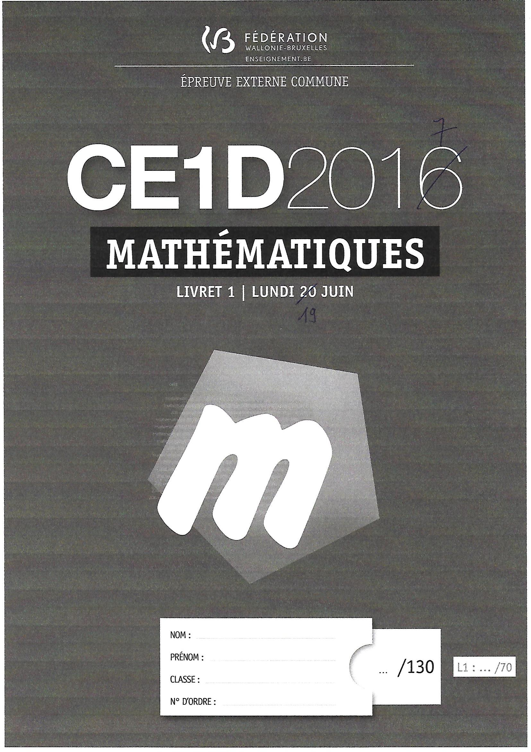

Front page of SCIENCES 2016 2017; MARDI 21 JUIN JEUDI 15 JUIN
